Driver Installation Under Win 95 OSR2.1

1.Step1: Double click "My Computer" →"System Properties"→"Device Manager"
Step2: While installing USB Data Link Cable under Windows 95 OSR2.1 mode, make sure "Universal Serial Bus Controller" is displayed under "Device Manager" first. If not, please refer to the Microsoft Web site at www.microsoft.com to find the Windows 95 USB support update file.
Step3: Plug in the Data Link Cable to the USB connector of your computer. See Figure 1

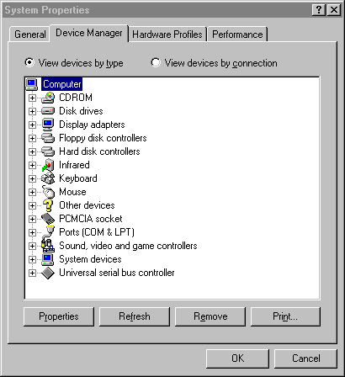
Figure 1

2. Step 1:Place the CD Driver supplied with your USB Data Link into the CD ROM.
Step 2: Enter the PC Data Link driver(V1.6) subdirectory and click "Setup" icon. See Figure 2
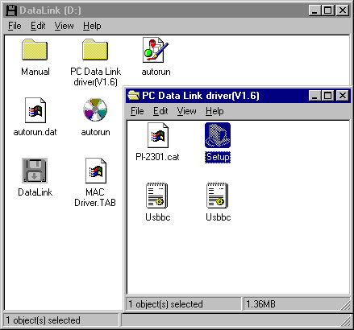
Figure 2

3. Click " Next " at the Welcome screen. See Figure 3

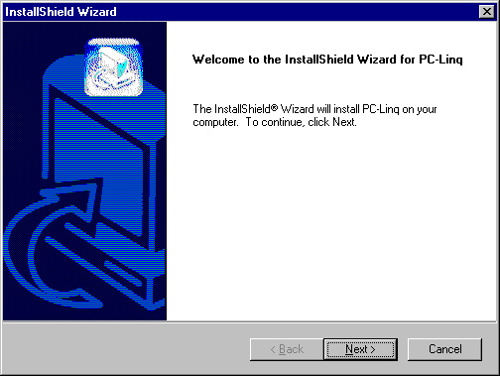
Figure 3

- Click "Next" at the "Choose Destination Location" screen. See Figure 4
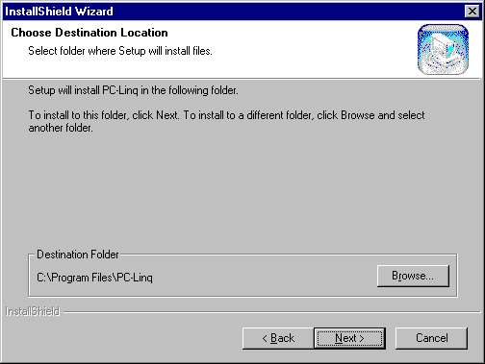

Figure 4

- Click " Next " to continue. (Type a new folder name or select one from existing folder list.) Then, click "Finish" button. See Figure 5
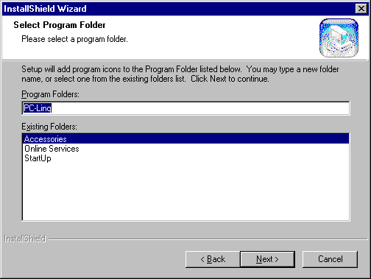
Figure 5

6. Return back to the "Device Manager" under " System Properties" and check if "USB Bridge Cable" is displayed, then click the "OK" and restart your computer to complete your installation. See Figure 6
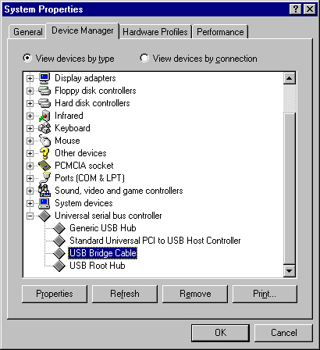
Figure 6

7. After restarting your computer, the PC-Linq icon will be displayed on the desktop. See Figure 7

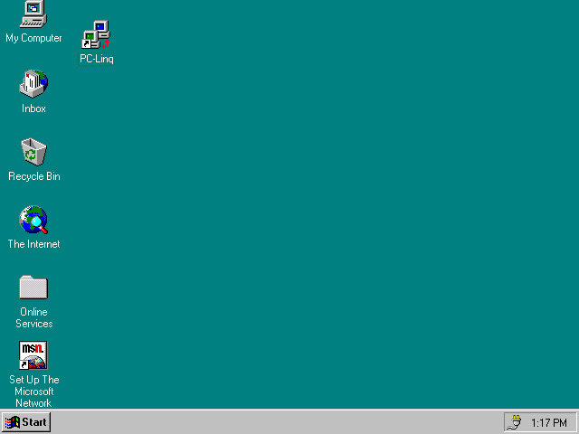
Figure 7

- Repeat the same procedure (1-7) with the other computer. And, click both computers' PC-Linq icons, then you can see the "Local Machine" & "Remote Machine" windows to start transferring data between the two connected computers. See Figure 8

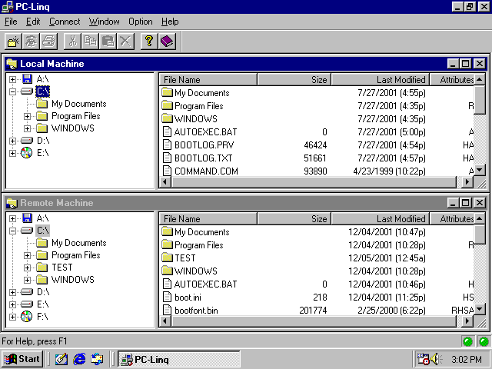
Figure 8

Driver Installation Under Win 98 / 98 SE / ME

1. Step 1: Plug in the Data Link Cable to the USB connector of your computer.
Step 2: Click " next" at the Add New Hardware Wizard screen. See Figure 1

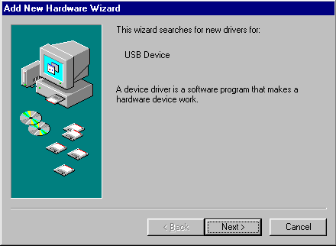
Figure 1

2.Click " next " to search for the best driver for your device. (Recommended) See Figure 2

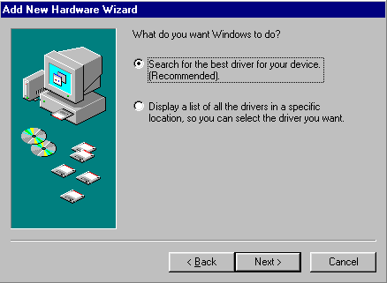
Figure 2

3.Specify “PC Data Link Driver (V1.6) “ folder under CD ROM driver and clink” Next “ See Figure 3

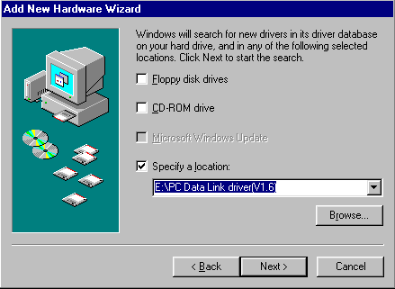
Figure 3

4.Windows driver file will search for the USB Bridge Cable, click " next " to continue. See Figure 4

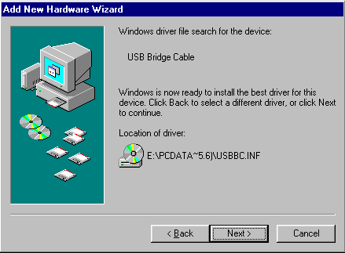
Figure 4

- Windows has successfully finish installing USB Bridge Cable software, click "Finish" button to close the Wizard. See Figure 5

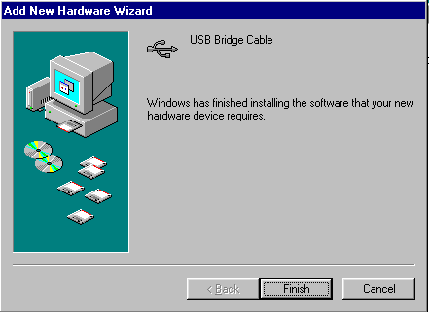
Figure 5

6. Step 1: Place the CD Driver supplied with USB Data Link into the CD ROM.
Step 2: The InstallShield@Wizard will install PC-Linq on your computer. Click "next" to continue. See Figure 6
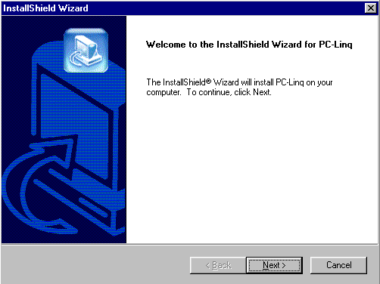
Figure 6

7.Click "next" at the "Choose Destination Location" screen. See Figure 7

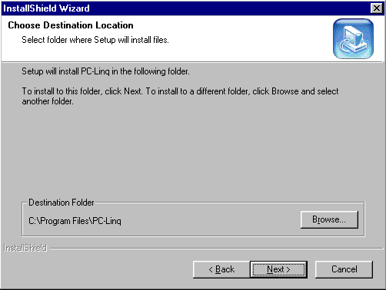
Figure 7

8. Type a new folder name or select one from the existing folders list. Click " next" to continue. See Figure 8

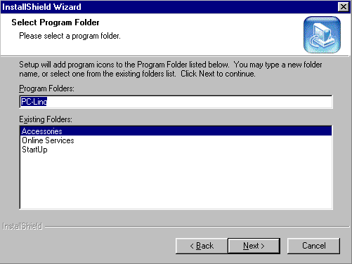
Figure 8

- PC-Linq icon will be displayed on the desktop. See Figure 9

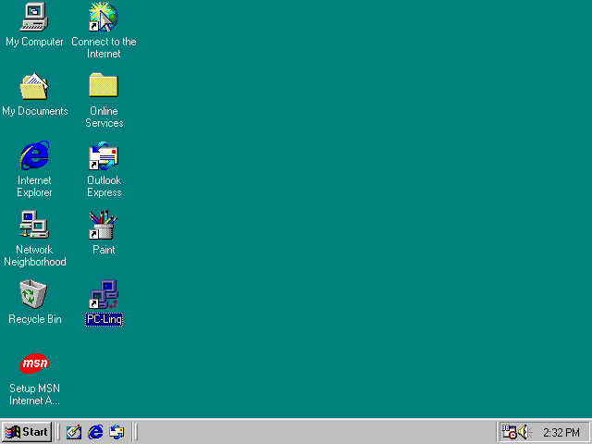
Figure 9

10.Return to the "Device Manager" under "System Properties" and check if "USB Bridge Cable" is displayed. Then, click the "OK" and restart your computer to complete your installation. See Figure 10
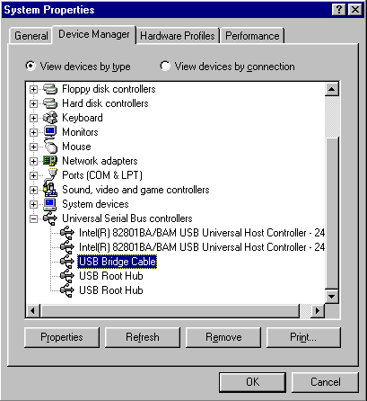
Figure 10

11. Repeat the same procedures (1-10) with the other computer. And, click both computers' PC-Linq icons, then you can see the "Local Machine" and "Remote Machine" windows to start transferring data between the two connected computers. See Figure 11

Figure 11

Driver Installation Under Win 2000

1.Step 1: Plug in the Data Link Cable to the USB connector of your computer.
Step 2: Click "next" at the welcome screen. See Figure 1

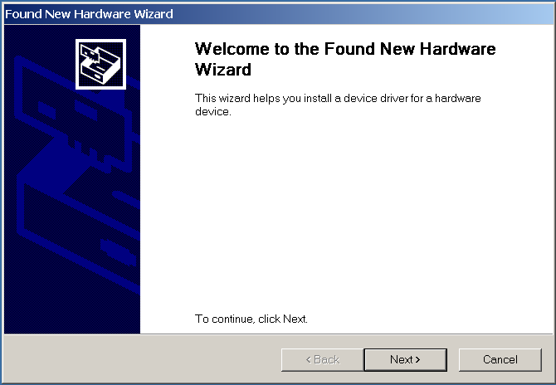
Figure 1

2.The "Found New Hardware Wizard" will install the USB Bridge Cable automatically. Click "next" button to search for a suitable driver (default and recommended). See Figure 2

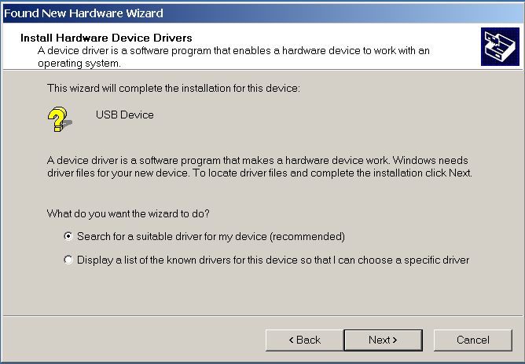
Figure 2

3. Choose "Specify a location" and click "next". See Figure 3

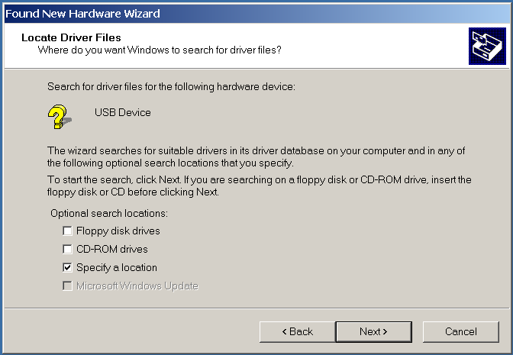
Figure 3

4. Locate the file "USBBC" under 'PC Data Link driver(V1.6)' folder in the CD driver supplied with USB Data Link. See Figure 4
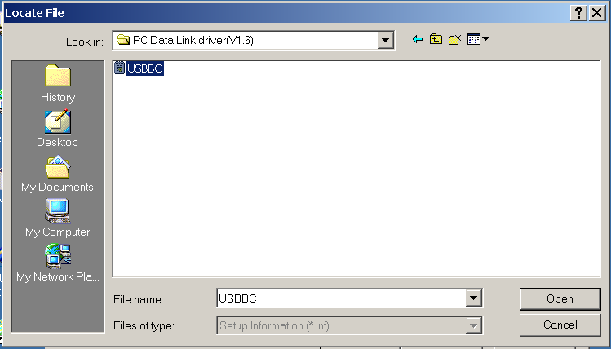
Figure 4

- Back to "Found New Hardware Wizard" screen and click "OK". See Figure 5
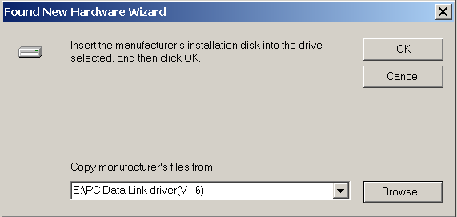
Figure 5
6. The Wizard has successfully located the drive, click "next" to continue. See Figure 6
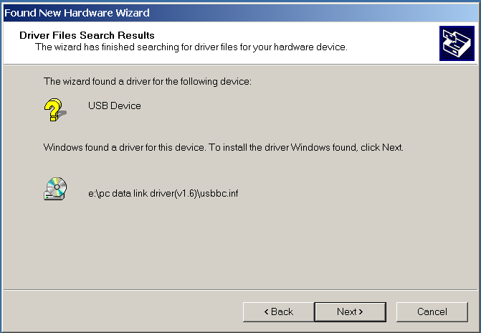
Figure 6
7. Click " Finish " to close the Wizard. See Figure 7
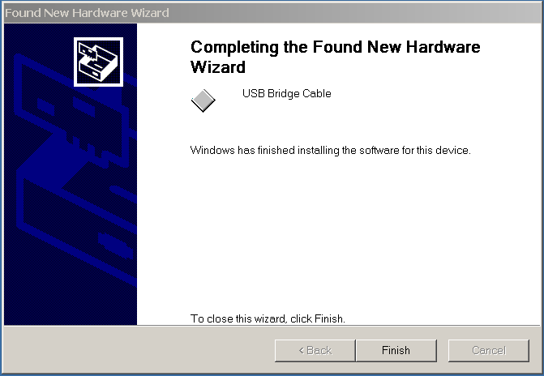
Figure 7

- Step1: Place the CD Driver supplied with USB Data Link into the CD ROM.
Step 2;The InstallShield@Wizard will install PC-Linq on your computer. Click “ next” to
continue. See Figure 8
Figure 8

9. Click “next” at the “Choose Destination Location” screen. See Figure 9

Figure 9

10.Type a new folder name or select one from the existing folders list. Click “next” to continue.
See Figure 10

Figure 10

11. PC-Linq icon will be displayed on the desktop. See Figure 11

Figure 11

- Return to the “Device Manager” under “System Properties” and check if “USB Bridge Cable” is
displayed. Then, click the “OK” and restart your computer to complete your installation. See
Figure 12

Figure 12

- Repeat the same procedures (1-12) with the other computer. And, click both computers’ PC-Linq icons, then you can see the “Local Machine” & ”Remote Machine” windows to start transferring data between the two connected computers.. See Figure 13.

Figure 13

Driver Installation Under Win XP

1. Step1: Plug in the Data Link Cable to the USB connector of your computer.
Step 2: Click "next" at the welcome screen. See Figure 1

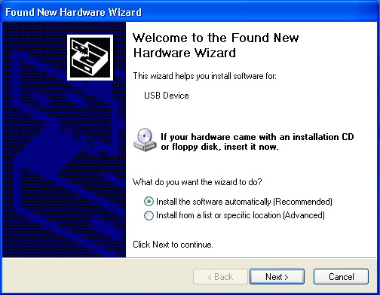
Figure 1

2. The "Found New Hardware Wizard" will install the USB Bridge Cable automatically. Click "Finish" button to close the wizard. See Figure 2
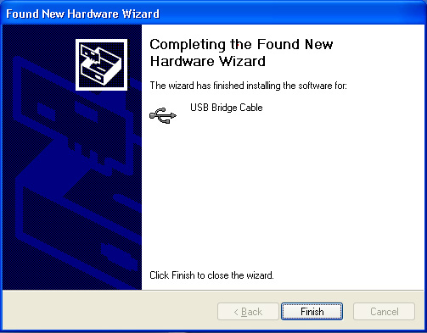
Figure 2

3. Step1: Place the CD Driver supplied with USB Data Link into the CD ROM.
Step 2: The InstallShield@Wizard will install PC-Linq on your computer. Click " next " to continue. See Figure 3

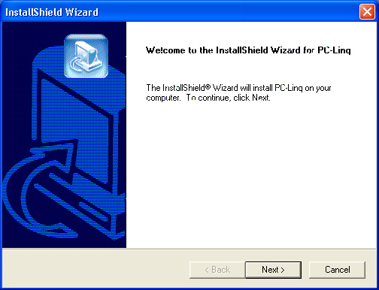
Figure 3

- Click " next " at the " Choose Destination Location " screen. See Figure 4

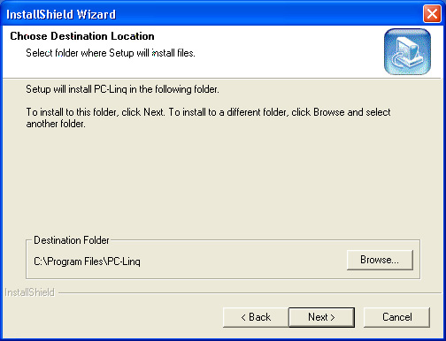
Figure 4

5. Type a new folder name or select one from the existing folders list. Click " next " to continue. See Figure 5
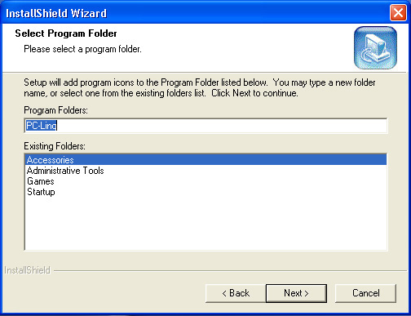
Figure 5

6. PC-Linq icon will be displayed on the desktop. See Figure 6

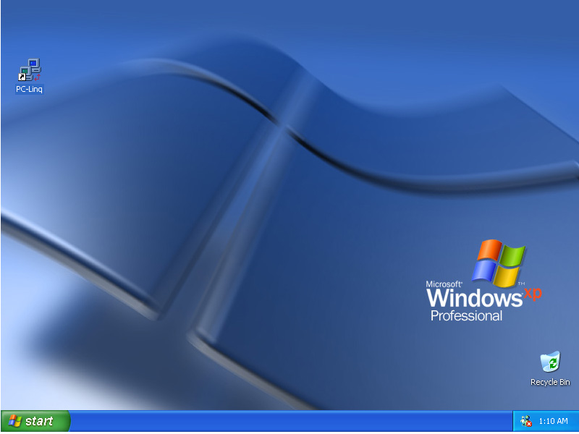
Figure 6

7. Return to the " Device Manager" under "System Properties" and check if " USB Bridge Cable" is displayed. Then click the "OK" and restart your computer to complete your installation. See Figure 7
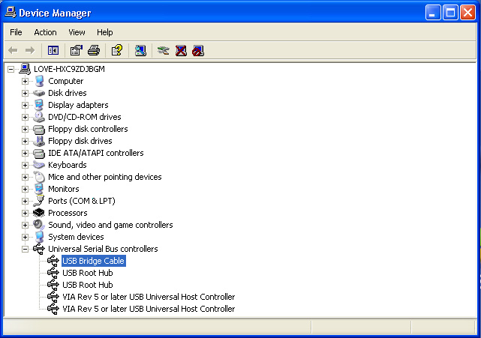
Figure 7

8. Repeat the same procedure (1-7) with the other computer. And, click both computers' PC-Linq icons, then you can see the "Local Machine" & "Remote Machine" windows to start transferring
data between the two connected computers. See Figure 8

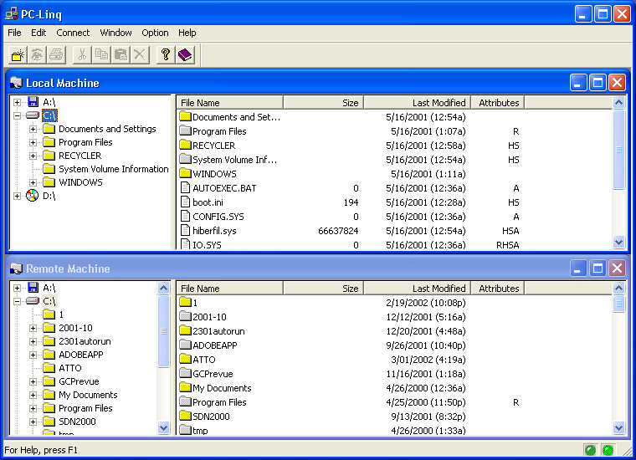
Figure 8

