PS2 and PC can transfer file with USB1.1 Link cable

More and more games are developed out nowadays, the old PS2 memory card is too small to meet with the demands of capacity for game-saves. Datel company(original name: CODEJUNKLE) who has developed out Action Replay 2 before, now developed out a new soft named Xport2, Xport 2 can perform the function of high speed transfer between PS2 /PC and the function of codes management if you connect with a USB Link cable.
It is important to consumer that Xport2 is free of space. If you buy a USB link cable, you can get all the function.
Preparation
1 Xport2 file name: xportv2uswebinstall.exe. file size about:3.01MB
2. Startup disk of XPort2 PS2
Open directory “XportV2”,It will show “XportV2.bin” and “XportV2.cue” two files, please use the Alcohol 120% applications to CD burning.
3.Alcohol 120％
Run the Alcohol 120％，select“File－Image Burning Wizard...”。（image 1）
Click “Browse…”,select the original “XportV2.cue”.(image2)
Be careful to select “Normal CD” before burning data type, not to select the default “PlayStation2”(image3)

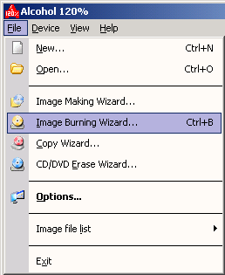
image 1
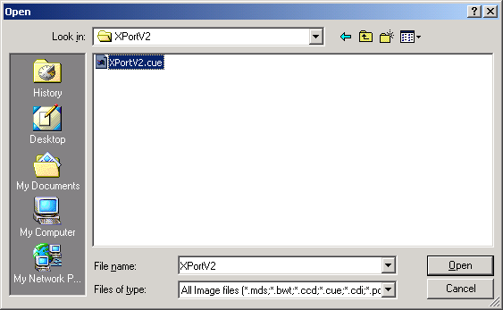
image 2
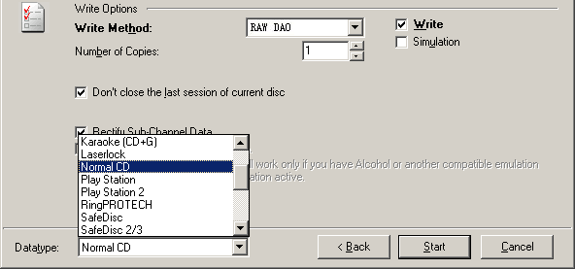
image 3

Operate manual
1.Operate process
ａ.Install X-Link driver on the USB Link cable, be careful not to install the driver inside USB.
ｂ. Burning a X-Port CD-ROM( for PS2 use)
ｃ. connect PC and PS2 with the USB Link cable
ｄ. start up the X-Port application on PC.
ｅ. open the power on PS2, plug PS2 startup disk in the X-Port begin to start up.
ｆ. When the “waiting for command” is show in window of PS2, you can start to operate the processes pertain to memory card of X-Port V2 application on PC.
Remark: The words “waiting for command” will flash on PS2 while the system reading memory card on PC.
2. Operate the system should comply with the above steps, especially the process from C-F. USB identification may be error if operate PS2 first and then operate PC.
3. if you operate the system following the above steps, the words of (USB link cable, memory card reads error )will be shown on PC, there must be some trouble with PS2 main frame. The PS2 mainframe should be amended , the possible problems maybe as below:
ａ. some crystal are compatible with USB
ｂ. USB port broken

Detailed manual for use and install
1.Installation the XPort2 software。
2.Install the USB Link cable
A. When USB 1.1 Link Cable plug to USB port for the computer ,then shown Found New Hardware
Wizard the diagram as below（image 4）.
B. At the following prompt,select Search for a suitable driver for my device (recommended)
option and click Next.（image 5）.
C. select Specify a location option and click Next, then select the path for driver
（image 6）.
D. Select the file location to the drivers in the Xport2 install catalogue ,you can
see the file of Xlink.inf.
Remark: Be careful not to install the driver in the CD-ROM taken by USB1.1 Link cable
on this step, you should select the install “\Drivers\Xlin.inf”in Xport2 install catalogue.(image7)
E. Continue next step after (image8) shows
F. Finished installing for this cable
G. You can see the cable “My Computer － Properties － Hardware － Device Manager...”
since Finished installing (image10)
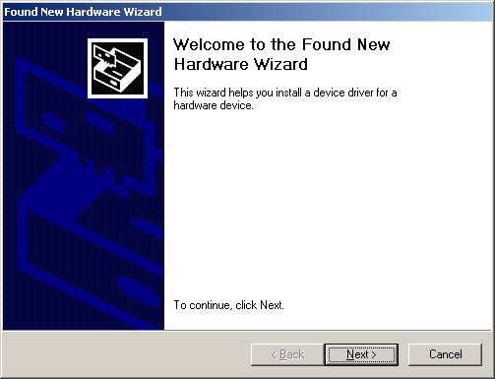
image 4
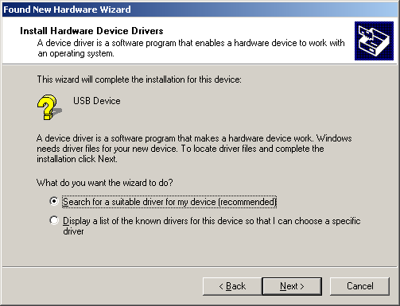
image 5
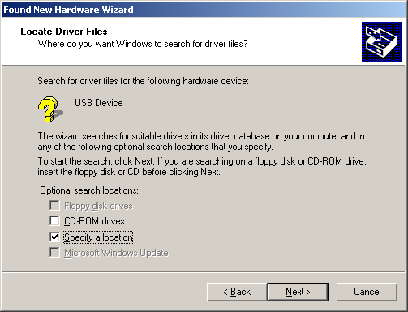
image 6
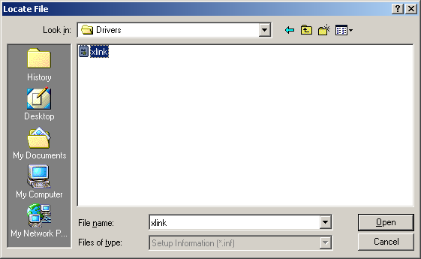
image 7
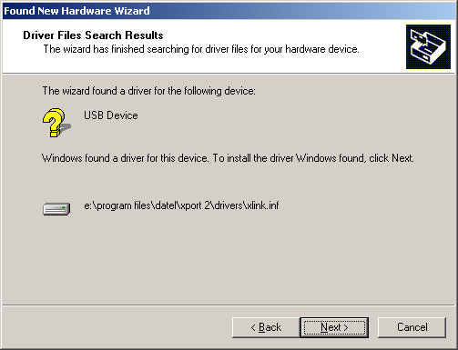
image 8
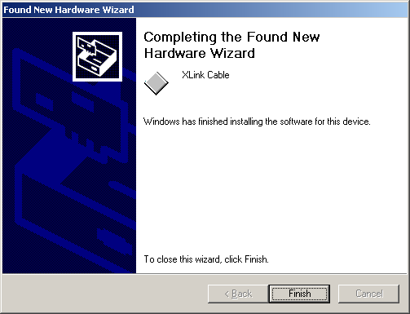
image 9

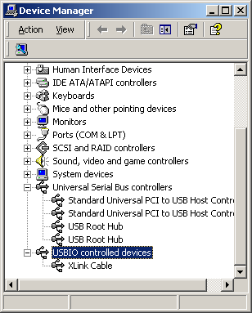
image 10

3. Use USB1.1 Link cable to connect PC and PS2, be careful to use the USB surface on PS2.
4. Run the Xport2, (image11)the computer will show the diagram

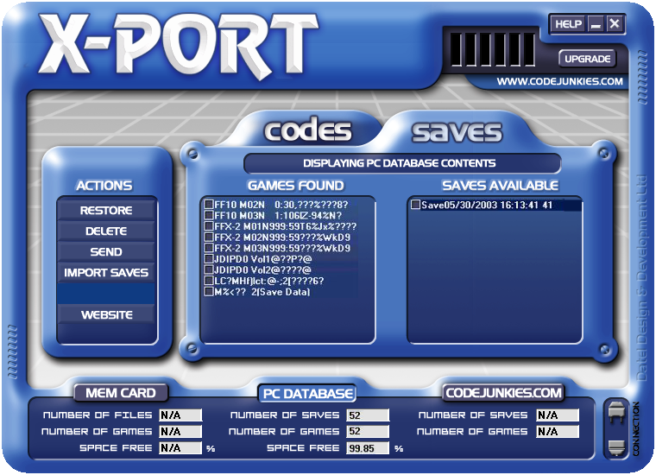
image 11

Start up the PS2, put in the Xport2 startup disk, then push Reset button, when the words “waiting for command”shows on the monitor, the step is over.
Is the blue surface familiar to you ? yes, it is the company who developed the common products Action Replay 2 Datel products
continue to operate on the computer, the words“wait for command” will flash while operating, if this words will not flash, reset the PS2 button again.
MEMORY CARD：Press this button to view the game-saves on the current memory card.
PC DATABASE：Press this button to view the contents of your PC Database.
game-saves is stored in the “savedgames” catalogue in Xport2 install catalogue.
Manual direction
RESTORE：Restores the checked game-saves to the current memory card.
You can select more files to copy at one time, if the same name is inspected while copy, game-saves
will reminder you to cover or not.USB surface port is faster than printer port, it depends on the file
sizes of game-saves. If your main board supports USB2.0,it can only use flash to describe.
DELETE：Delete the currently checked game-saves from your PC Database.
Be careful to use this function, in general,Xport2 will take some game-saves after install.
Be careful while delete the files, do not delete the useful game-saves.
SEND：Send the currently checked game-saves by Email or to a directory.（image 12）

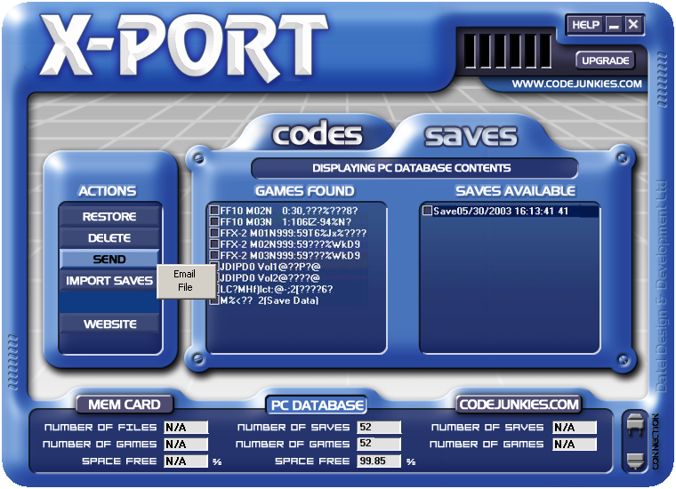
image 12
The sub-file of Xport2 game-saves is .xps, it supports the format of .xpo in original revision Xport1.maybe some consumersthought that if they have many game-saves and transfer them one by one, it will be very complicated.
yes, it is very complicated. It will be very inconvenient to handle many documents. Datel has considered consumer’s thought and they develop out the format of .db game-saves which involves many game-saves .
(in fact ,it has not so many game-saves, a game-saves only can involves 32767pcs game-saves, it is enough). Single file of game-saves is .xps file while sending game-saves, multi-selection is .db document. It is very convenience.

IMPORT SAVES：Import game-saves from files.
It can support above three formats at the same time, the new game-saves will be shown in
the list after install （image 13、14）.

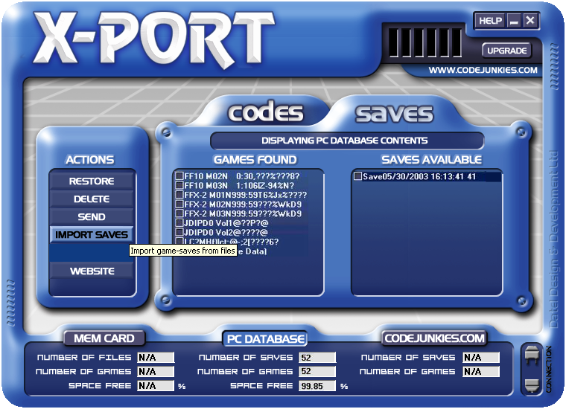
image 13

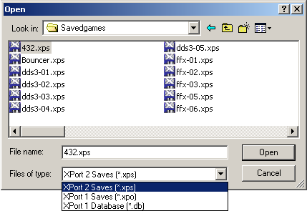

image 14
WEBSITE：Visit the Website of XPort.
you can see it yourself. Maybe it seem has stopped to renew.
MEM CARD：Press this button to view the game-saves on the current memory card.
will be shown while connecting(image15), your memory card list will be shown after succeed in
connecting. (image16)
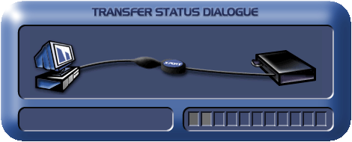
image 15

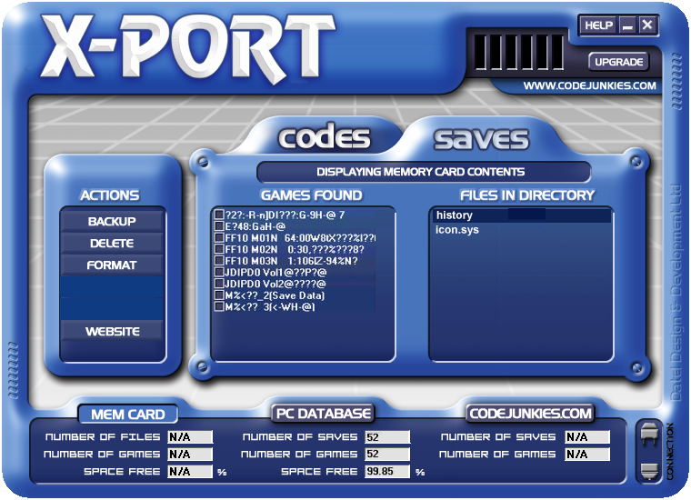
image 16
It will shows in the menu after click the AR2 DONGLE(image17), please reset the PS2 button.

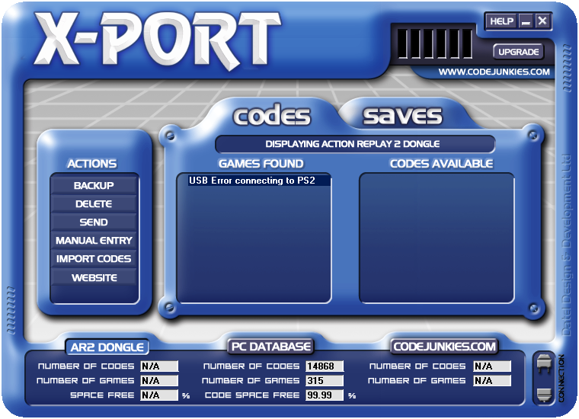
image 17
BACKUP：Backup the currently checked game-saves to your PC Database.（image 18）
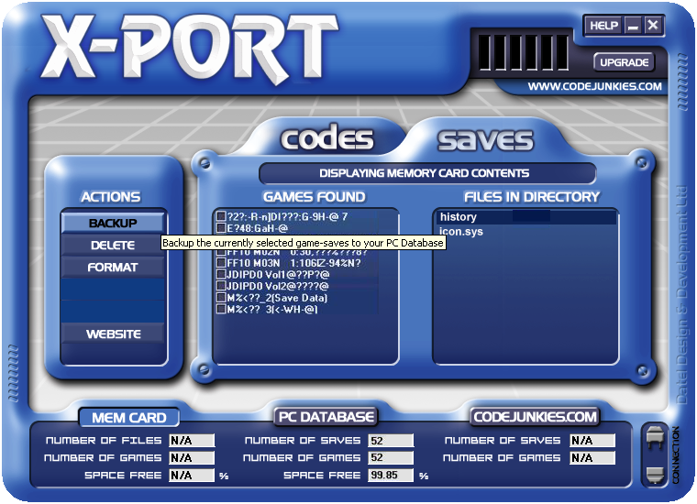
image 18
DELETE：Delete the currently checked game-saves from your memory card.
It is the same as above, but this is the game-saves in the memory card which has been deleted. Anyway, if there is one broken game-saves which can not be deleted by PS2 in memory card, this function can be put to use..
FORMAT：Format the memory card currently inserted.
be careful to use. If you meet the broken game-saves which can not deleted(maybe it will not occur), this is the only you can select.Do remember to backup the useful game-saves.
Manage Action Replay 2 codes
As Action Replay 2 is Datel company’s product, Xport2 also has the function of Action Replay 2, but it only comply
with Action Replay 2 codes+ Action Replay 2, it does not limit the revision.It also does not support other
company’s products.
AR2 DONGLE：Press this button to view the cheats on your Action Replay cartridge.（image 19）
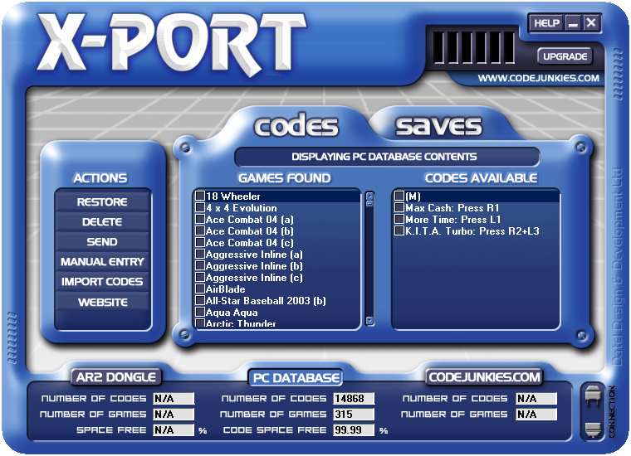
image 19
Click AR2 DONGLE ,enter into the Managing Action Replay 2 codes.
Remarks: Before use the manage function of Action Replay 2 codes, please plug Action Replay 2 dongle into memory card port 1. The other cautions are similar to Memory card.Likewise, you should plug memory card into the port 1 if you want to Managing saves on your memory cards.
RESTORE：Restores the checked game-saves to the current memory card。
And also you can select more files to copy in one time. If one game has multi-lines of codes, you can select the files which need to copy on the right of the windows only. If the same codes can not be covered in Action Replay 2 dongle which can not be covered while copy, it will add the not-repeated codes. Operate the backup function is the same as copy file from Action Replay 2 dongle to PC.
Example: FF10-2, there are three item“main codes,money,prop 99pcs”on the computer codes, only FF10-2 which on Action Replay 2 dongle has main code and money.
It can be added up to “prop 99pcs”automatically after backup ,the other two item will keep the same.
select one game, click the right button on the right of the windows and select “add new codes”, add “Add new codes”manually, also you can delete it
DELETE：Delete the currently checked codes。.
SEND：Send the currently checked codes by Email or to a File。
The sub file name of Xport2 codes is .xpc, old revision Xport1 has not the management function of codes and use .gsc developed by GameShark to replace it.
There are two reasons for no need to use the .db format of game-saves, one is that if the sub-file name repeated, it will be hard to manage, another reason is .xpc has .db function of game-saves, it can store the transfer function of many codes into a .xpc file.(it also has the limit of 32767 files)

MANUAL ENTRY：Manually enter new Action Replay codes。
People who plays Action Replay 2 usually do not want to key in CODES one by one, in general ,the game codes are downloaded from internet or codes magazine. A game nearly has 5-6 lines of codes, for example, the big combat plane FF has about 100 lines of codes.
If add some props, the lines of codes will be more than others. Simply a RPG also has hundreds of props. So many consumers says that they have time to key in codes and have no time to change game. The game has passed three times without change.
It’s nice that customer’s nightmare has settled and died away. Manual input function is suitable for some lazy person, it is more convenient to input into computer than key in the words one by one.
if you can find CODES on internet, Do remember to use the copy method. But every Dongle should be divided into two segments. In addition, you can add following description , otherwise, you may not know what the function is. (image20)
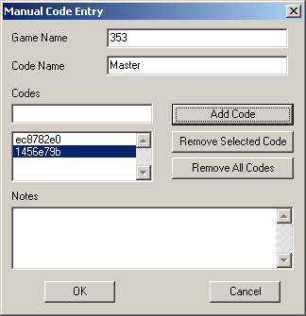
image 20
IMPORT CODES：Import codes from a file。
It can supports many format and renew list .
WEBSITE：Visit the website for XPort。
Method: you can click right button to select or delete when select saves/ codes.
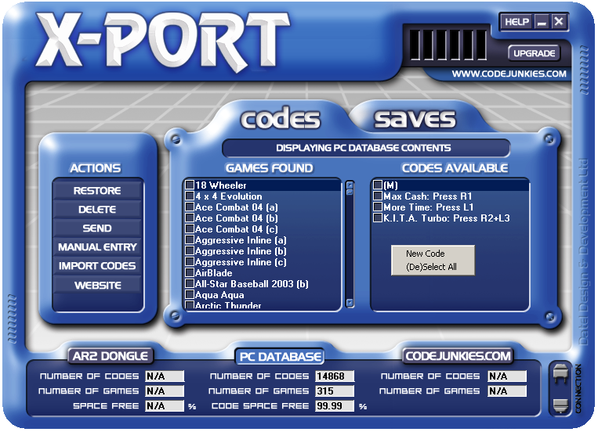
image 21
I have tested this device, the security is very well. It will not mar the memory card while the machine is dead or electricity shut off or plug out the power cable.Though the memory card will not be marred, it is not available to the SAVES inside MEMORY CARD, hence, please do not make the computer dead or shut off the electricity or plug out the power cable.
Questions and answers
1. Q: Does the Action Replay 2 of CD-ROM must use the revision above 2.0?
A: Yes, Only above revision 2.0 can support the function of USB transfer.
2. Q: Why can’t I install this driver ?
A: The USB transfer cable which can supports Xport is Prolific PL2301 at present, The Xport you are using
maybe no usefule, it is not true that every USB transfer cable can compliant with Xport.
3. Q: Why can I manage memory card and can not manage Dongle ?
A: You should plug Dongle into memory card slot 1, then you can use the management function of Dongle. It is the same that you should plug the memory card into the slot 1 to manage memory card.
4. Q: Why the system always stop when I operate the management function of Dongle?
A: This is because the name and function code in Dongle are Japanese, once you delete the Japanese name in the Dongle or change the Japanese to English, the system will not stop.The other method is use Japanese windows as manager or set the words in 2000 or XP system as Japanese, it also can solve this problem. And the same method can solve the problem of power cable be shut when use GBA system.Many GBA customers did not know how to use this link cable maybe caused by this problem.
5. Q: I have not use AR2 before, what is that ?
A: AR2 is a DONGLE, the original AR2 is a CD-ROM and a bootable card , the size of bootable card is the same as memory card, and plug into the memory slot.Use this method, you just need a AR2 CD-ROM to finish this work. You can file first and then to download, then try to read in the PS2, when you see the image of PS2, the work is over. That means you should install a AR2 CD-ROM in your computer, if it can be read, then your cable can be put into use.

