GeneLinkTM User Guide

1. When you install the driver into the 1st Computer , please firstly install the software from the CD driver , and then put one end of the USB1.1 Link cable into a USB Port in the 1st Computer , and leave the other end of the USB1.1 Link cable unused .( Never connect it to any other computers ). ( Refer to image 1 )
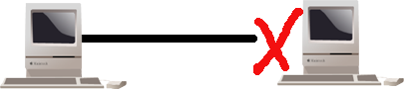
( image 1 )
2. When you put the USB1.1 Link cable into a USB Port in the 1st Computer , system will detect it and start to install , just follow up the installation guide to install it .

3. After you install the 1st Computer , please pull out the USB1.1 Link cable from the 1st Computer .

4. When you install the driver into the 2nd Computer , please firstly install the software from the CD driver , and then put one end of the USB1.1 Link cable into a USB Port in the 2nd Computer , and leave the other end of the USB1.1 Link cable unused ( Never connect it to any other computers ). ( Refer to image 2 )
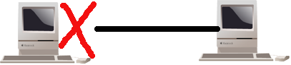
(image 2)
5. When you put the USB1.1 Link cable into a USB Port in the 2nd Computer , system will detect it and start to install , just follow up the installation guide to install it .

6. After you install the 2nd Computer , please pull out the USB1.1 Link cable from the 2nd Computer .

7. Restart the both computers , and link the both Computers with USB1.1 Link Cable , then you can run it . ( Refer to image 3 )

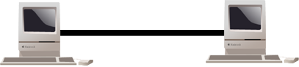
( image 3)

Installing USB TO Network Cable :
Follow the steps below on installing the USB TO Network Cable software:
- Power on your computer and make sure that the USB port is enabled and working properly.
2. Please double click "setup.exe" to get " image 1 ".
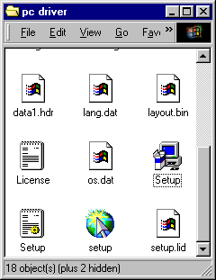

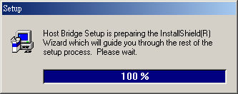
image 1

3. Please click " Next " continue to install.
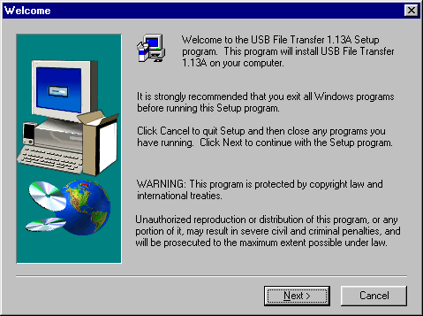
4. Please click " Yes" to continue installing.
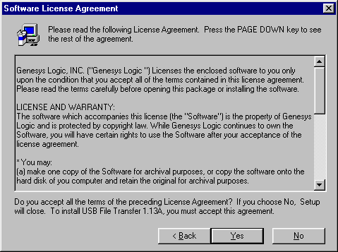

5. If it's installed to a different folder, Please click Browse and select another folder. Then click
" Next " to continue installing.
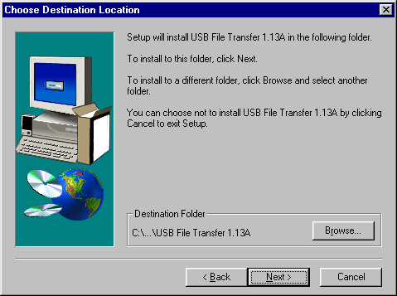
6. After windows copy the needed files to the system, it will get the following interface. Then, Please
connect the USB Link Cable to the USB PORT of the computer, And click " Finish " It's will install the USB Link Cable automatic.
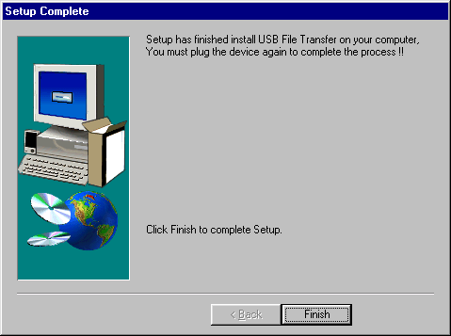

7. It will show following icon .
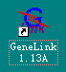
8. Move the course on “My Computer” icon as below. Double-click the icon to open “My
Computer”, you will see “ Removable ”; and then click the right button of mouse and a pull-down window appears. Select the latest item-“Properties”.
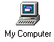
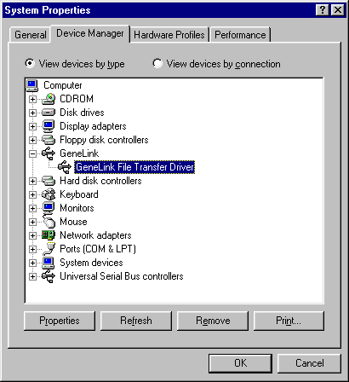

application in practice:
- Please double click "GeneLink 1.13A" which on the desk up to get "image 2 " .
- It means having not been connected. (Image 2)
- It means being on connection. (Image 3)
- It means being connected. Meanwhile, the " Remote Desktop " on the right will display the other
computer’s catalogue. (image 4 )
- Select the folder & file which should be copy, then click or or to copy the folder & file to the corresponding computer.

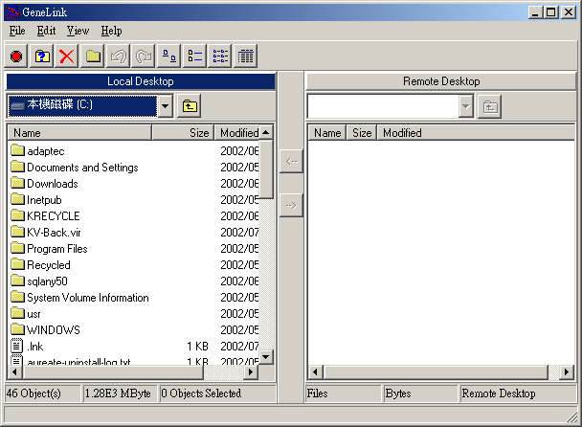
1
image 2
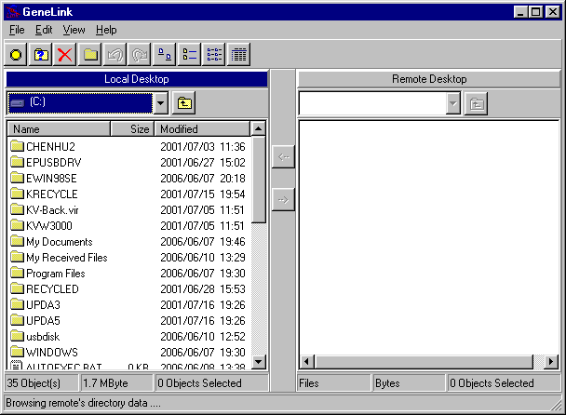
2
image 3
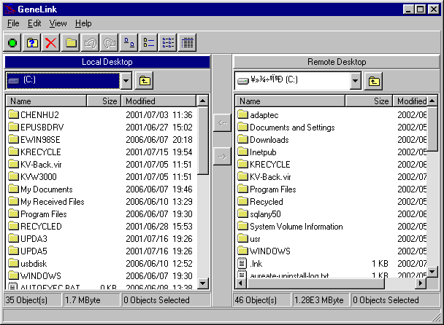
3
image 4
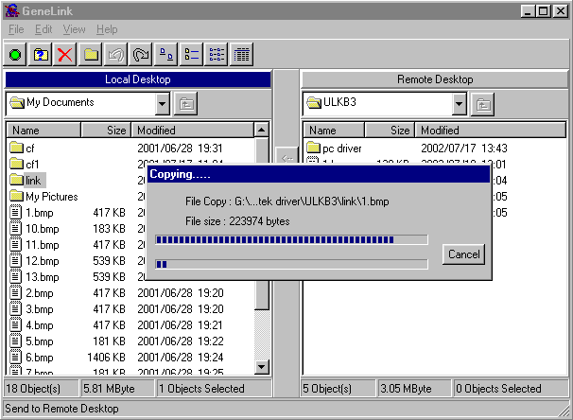

image 5
Remove USB TO Network Cable

- Firstly, Please pull out the USB Link Cable from the USB Port .
- Please open the " Control Panel " ;Then double click " Add/Remove Programs " up to get Image 6 .
- Please select " USB File Transfer 1.13A" , and click " Add/Remove " on the right . Then remove USB Link Cable .

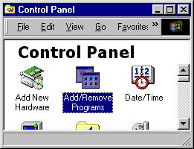
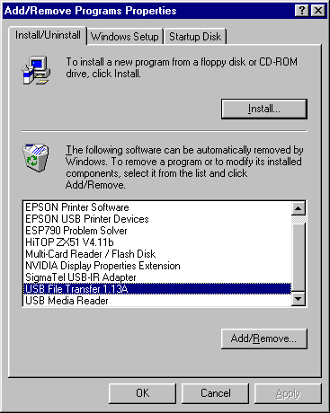
image 6

