GeneLinkTM User Guide
1.Overview
2. Driver Installation
3. Build up your GeneLinkTM LAN
4. Connecting to your existing Home or Office LAN

1. When you install the driver into the 1st Computer , please firstly install the software from the CD driver , and then put one end of the USB1.1 Link cable into a USB Port in the 1st Computer , and leave the other end of the USB1.1 Link cable unused .( Never connect it to any other computers ). ( Refer to image 1 )
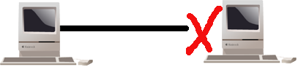
( image 1 )
2. When you put the USB1.1 Link cable into a USB Port in the 1st Computer , system will detect it and start to install , just follow up the installation guide to install it .

3. After you install the 1st Computer , please pull out the USB1.1 Link cable from the 1st Computer .

4. When you install the driver into the 2nd Computer , please firstly install the software from the CD driver , and then put one end of the USB1.1 Link cable into a USB Port in the 2nd Computer , and leave the other end of the USB1.1 Link cable unused ( Never connect it to any other computers ). ( Refer to image 2 )
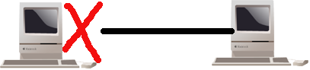
(image 2)
5. When you put the USB1.1 Link cable into a USB Port in the 2nd Computer , system will detect it and start to install , just follow up the installation guide to install it .

6. After you install the 2nd Computer , please pull out the USB1.1 Link cable from the 2nd Computer .

7. Restart the both computers , and link the both Computers with USB1.1 Link Cable , then you can run it . ( Refer to image 3 )

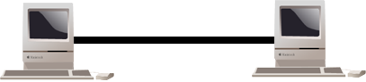
( image 3)

Overview
GeneLinkTM is the best solution for providing the easiest network connection service to you. By connecting multiple PCs through GeneLinkTM , you can build up a local area network without any network adapter. We give this Ethernet emulation environment a name -- GeneLinkTM LAN. GeneLinkTM supports TCP/IP, NetBEUI and IPX protocols. These features make your PCs can share their resources such as files or printers to each other. Further more, GeneLinkTM also give you the ability of connecting you GeneLinkTM LAN to your existing Home or Office LAN for network resource or Internet sharing.

Driver Installation
Attention : Please don’t plug in GeneLinkTM cable before GeneLinkTM driver is installed.
The driver installation procedures of GeneLinkTM will be separated in two sessions. First, we will let you know how to build up a pure GeneLinkTM LAN. That is, all PCs are connected via GeneLinkTM cable (for example, one PC and one Notebook). After that, we will tell you how to connect your GeneLinkTM LAN to your existing Home or Office LAN through the new advanced feature of GeneLinkTM.

USB Hub
GeneLinkTM
Peripheral Sharing

A sample GeneLinkTM LAN

Build up your GeneLinkTM LAN
The setup procedure is same for each computer if all your computers are connected via GeneLinkTM cable only. GeneLinkTM LAN driver must be installed in each computer of GeneLinkTM LAN. The installation procedures are described as follows :

Step 1. Install driver
- Insert the GeneLinkTM setup diskette into your floppy disk drive.
- Run GeneLinkDriver.exe and the welcome dialog box appears.

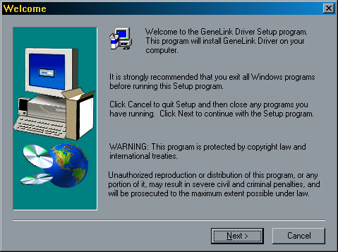
- Click ‘Next’ button.
- Choose the destination folder. If you don’t want to install the driver in the default folder, click ‘Browse’ button to select another folder. Click ‘Next’ button.

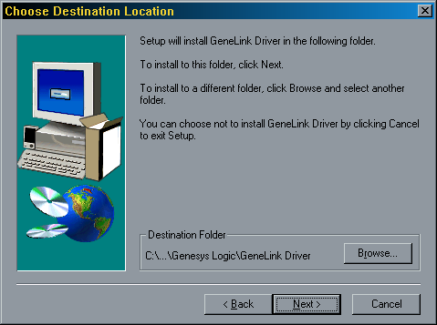

- Select components that you want to install. Leave ‘GeneLinkTM Software Router’ unchecked, then click ‘Next’ button.

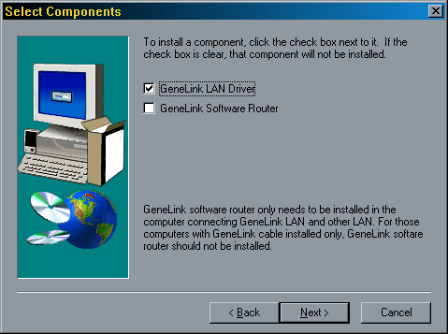
- The Setup Program will install all necessary components for GeneLinkTM automatically.
- Setup complete. Then Setup Program will ask you to reboot you computer for updating your driver configuration.

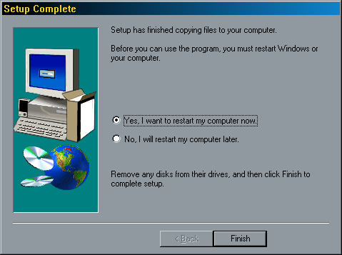
- Remove GeneLinkTM Setup Diskette from your floppy disk drive. Select ‘Yes, I want to restart my computer now’ radio button and click ‘Finish’ button to reboot your computer.

After you complete the installation procedures, you’ll find Setup Program has installed GeneLinkTM network driver in your computer. It binds TCP/IP, NetBEUI and IPX protocols to GeneLinkTM device. Therefore, those computers which connecting to GeneLinkTM LAN can communicate with each other in TCP/IP or NetBEUI protocol. One last thing, please double-check if you define the same name for two or more computers within GeneLinkTM LAN. If you do that, name conflict will occur, and your GeneLinkTM LAN won’t work.

Step 2 - Network Login
When your restart your computer, you will be prompted for a user name and password to login your network.
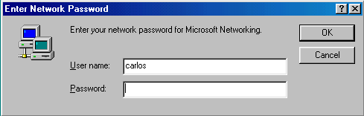
Enter a user name and a password when you prompted. This user name should be a unique name for your desktop or notebook; otherwise, you’ll cause a network conflict and make your network mal-function.
Notice: Entering a Password is optional. If you don’t enter your password when you were prompted for a user name and password in the very first time, you can just click “OK” button at network login screen to complete your login procedure. But remember, please don’t just press “ESC” or click “CANCEL” button to bypass this login screen, or your GeneLinkTM cable may not work correctly.

Step 3 – Connect the GeneLinkTM cables
Well, it’s easy. Just find an available USB port on your Desktop/Notebook and plug GeneLinkTM cable in it.

Step 4 – Sharing your resource
You need to manually share your resources to make your resources (files, folders, drives and printers) accessible for other computers. Similarly, other computer’s resources have to been shared if you want to access them.

How to share your files, folders, drives and printers
- Go to the file, folder, drive or printer that you want to share.
- Right click your mouse pointer on the resource you want to share, you’ll see a POP-UP Menu.
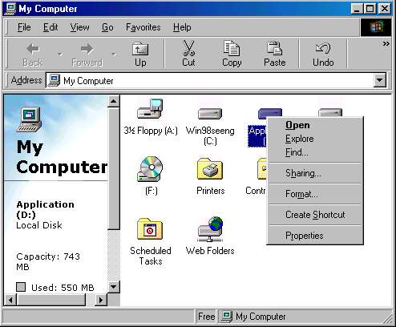

- Select “ Sharing”, and you’ll see another Pop-Up Menu.
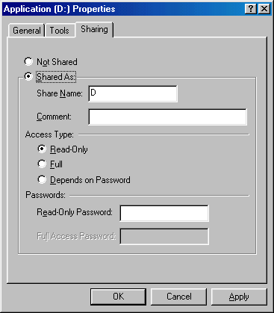
- In “Sharing” tag, select “Share As”.
- Enter a name to help others recognize your sharing file or device (optional).
- Select “Access Type”. If you select “ Depend on Password”, your need to assign an access password for this device.
- Click “OK” button.

How to check if you have already shared your resource?
Go to the resource and check if Windows had added a hand on its icon or not. If yes, it means you’ve successfully shared your resource and you can access it through GeneLinkTM LAN; if not, you need to repeat “Sharing your files, folders, drives and printers” to complete your sharing processes and make your resources available on GeneLinkTM LAN.

Connecting to your existing Home or Office LAN
To connect your PC or GeneLinkTM LAN to another existing Home of Office LAN via GeneLinkTM cable, you need to install GeneLinkTM Software Router in addition to GeneLinkTM LAN driver. GeneLinkTM Software Router is responsible for handling all network packets between GeneLinkTM LAN and your Home/Office LAN. So only the computer that is physically connected to both LANs needs to install GeneLinkTM Software Router (i.e., this computer should install both GeneLinkTM cable for GeneLinkTM LAN and one network adapter for Home/Office LAN). For those computers on GeneLinkTM LAN, you only need to follow previous session (“Build up your GeneLinkTM LAN”) to install GeneLinkTM LAN driver for them. Following procedures will show you how to install drivers to the computer that will link both GeneLinkTM LAN and your existing Home/Office LAN:
Install Software Router in this computer !

GeneLinkTM
Internet

Ethernet

GeneLinkTM LAN

Step 1. Install GeneLinkTM Software Driver
- Insert the GeneLinkTM setup diskette into your floppy disk drive.
- Run GeneLinkDriver.exe and the welcome dialog box appears.

- Click ‘Next’ button.
- Choose the destination folder. If you don’t want to install the driver in the default folder, click ‘Browse’ button to select another folder. Click ‘Next’ button.

- Select components that you want to install. Click ‘GeneLinkTM Software Router’ check box. Click ‘Next’ button.

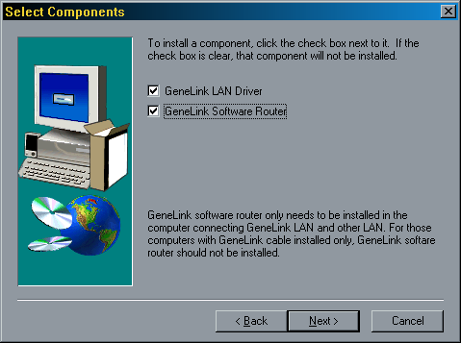

- The setup program will install all necessary components for GeneLinkTM automatically.
- Setup complete. Then Setup Program will ask you to reboot the system for updating your driver configuration.

- Remove the GeneLinkTM setup diskette from your floppy disk drive. Select ‘Yes, I want to restart my computer now’ radio button and click ‘Finish’ button to reboot your computer.
- After you install Software Router, you also need to install GeneLinkTM drivers for the Desktop/Notebook that would like to connect to this “Software Router” ready computer. To do that, please follow the instructions of “Build up your GeneLinkTM LAN”.

Notice: if you want to connect your GeneLinkTM LAN to your existing Home/Office LAN, you should use the same protocol for these two LANs. For example, if your Home/Office LAN uses TCP/IP protocol, you should also use TCP/IP protocol for your GeneLinkTM LAN. Otherwise, these two LANs cannot communicate to each other. The Setup Program installs TCP/IP, NetBEUI and IPX protocols for GeneLinkTM LAN by default. If your Home/Office LAN uses other protocol, please install the same protocol for those computers within GeneLinkTM LAN.

Connecting to Internet through GeneLinkTM cable

If you would like to access Internet resources through GeneLinkTM cable, here are something you should notice:
- You must define which computer should install GeneLinkTM Software Router;
- The computer which had installed GeneLinkTM Software Router should have already been connected to internet;
- All clients which would like to access Internet resources through GeneLinkTM cable should have installed GeneLinkTM driver.
Now we need to do some network configurations on the Desktop/Notebook which connect to GeneLinkTM Software Router to make your Internet access possible (maybe you need to consult you Network Administrator for doing that):
- If your existing HOME/OFFICE network is NOT using DHCP to assign client’s IP address, your need to:
- Move your mouse pointer on Network Neighborhood icon and right click on it. You’ll see a pop-up menu.
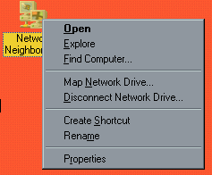

- Click on “Properties”, you’ll see another menu.

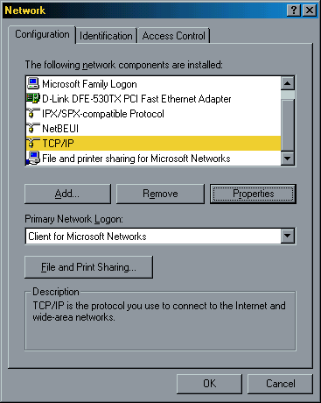

- Choose TCP/IP in Configuration tag, and then press “Properties” button. You’ll see “TCP/IP Properties” menu.
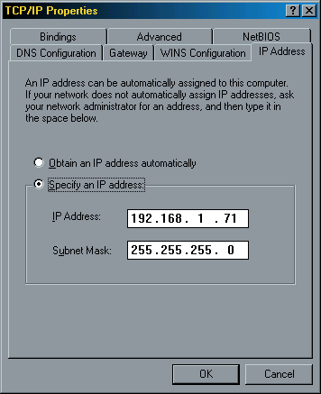

-Now you need to navigate between “IP Address”, “Gateway”, and “DNS Configuration” tags to specify “IP Address”, “Subnet Mask”, “Gateway” and “DNS Server”. If you don’t know their value, pleases consult your Network Administrator.

-Press “OK” button to go backward to “Network” pop-up menu. Choose “Identification” tag. Specify a unique name for your computer if it doesn’t have and fill the name of your workgroup. If you are not sure what’s the name of your computer or Workgroup, please consult your Network Administrator.
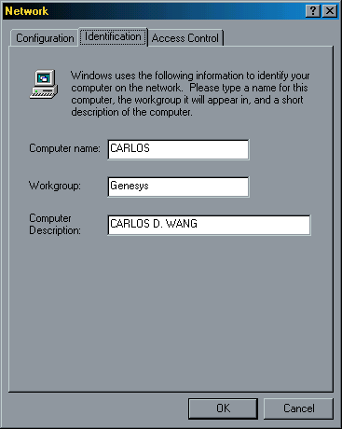

- Press “OK” to complete your network configuration. Restart your computer and you’ll be ready to connect to Internet.

- If your existing HOME/OFFICE network IS using DHCP to assign client’s IP address, your Network Sever will configure your network configuration automatically. So you can skip those procedures described in previous session.

SPECIAL NOTICE for those users who have already installed Network Adapter in their system:

If you’ve already configured your [IPX/SPX] and [Client for Netware Networks] before install GeneLinkTM driver, we strongly recommend that you should also install Software Router when you installing GeneLinkTM driver into your system. If you decide not to install Software Router, then the OS will not allow two IPX/SPX configurations co-exist in the same system. This will cause GeneLinkTM Driver Install Program overwrite your original IPX/SPX configuration and make your original network configuration malfunction.

